AWS LZA Deployment Guide
Contents

1. Introduction 2
1.1. Architecture Overview 2

2. Pre-Requisites 3
2.1. Setting up a Personal Access Token (PAT) 3

3. Deploying the initial Pipelines 5
3.1. What is the function of CodePipelines? 5

4. Configuring the LZA 6
4.1. What are the Configuration Files? 6
4.2. Where do I edit the Configuration Files? 7
4.3. What is the Use Case of the Configuration Files and How does it work? 7
4.4. How do the zipped files work? 8

Introduction
This guide is intended to provide an engineer with the necessary context to deploy and manage the AWS LZA (Landing Zone Accelerator) this project is supplied by AWS under an open-source license (Apache 2.0) on an as-is basis and maintained by AWS. The source code is hosted on GitHub and the project relies on AWS CDK There is also a User Guide which explains the concepts of the LZA in more detail. The LZA configuration utilizes the same name and function as the CDK classes, you can find these in the User Guide references section, for example, to understand what enabling region aggregation in SecurityHub within the security-config.yaml file we can follow this path:
References > SecurityConfig > centralSecurityServices > centralSecurityServicesConfig > securityHubConfig
The Version 1 standard LZA configuration is aligned to CIS 1.2 and AWS best practices, it was developed on release 1.9.2 of the LZA codebase. The LZA pattern is also a full implementation of the AWS Prescriptive Guidance SRA (Security Reference Architecture)

Architecture Overview
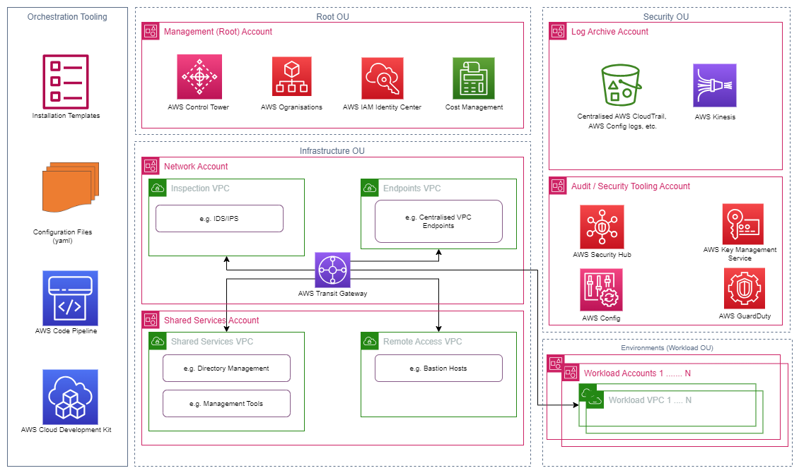

Pre-Requisites
- Administrative Access to an AWS account that is not part of an existing Organization
- A Control Tower Landing Zone setup (steps to be added)
- A GitHub PAT token – See 2.1 Below

Setting up a Personal Access Token (PAT)
- Set up a GitHub Account.
- Under your profile settings, choose ‘Developer Settings’.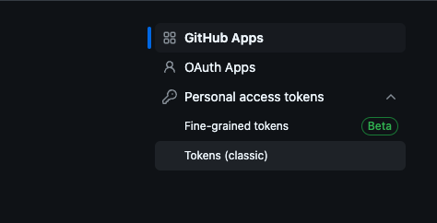
- Under Personal access tokens (PAT), choose tokens (classic), and generate a new access token – setting the scope as ‘public_repo’ (Access public repositories) with ‘No expiration’ selected. 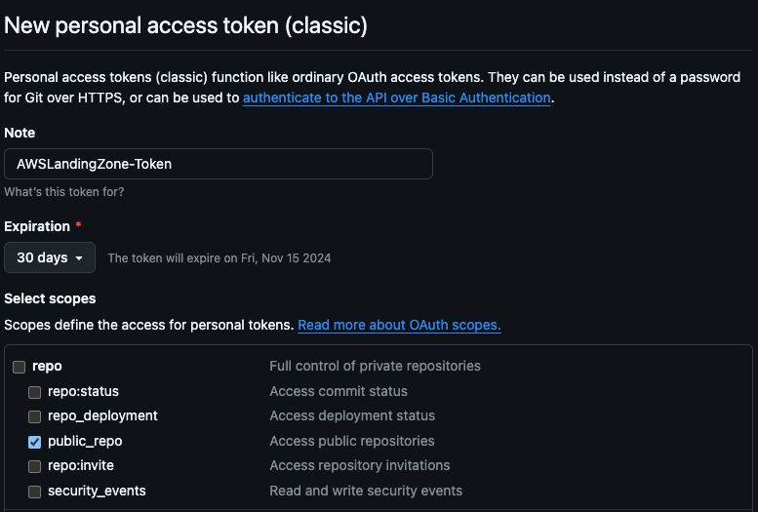

- Store your PAT in a Secrets Manager formatted as plaintext (Optioned as ‘Other type of secret’) with the name ‘accelerator-github-token'.
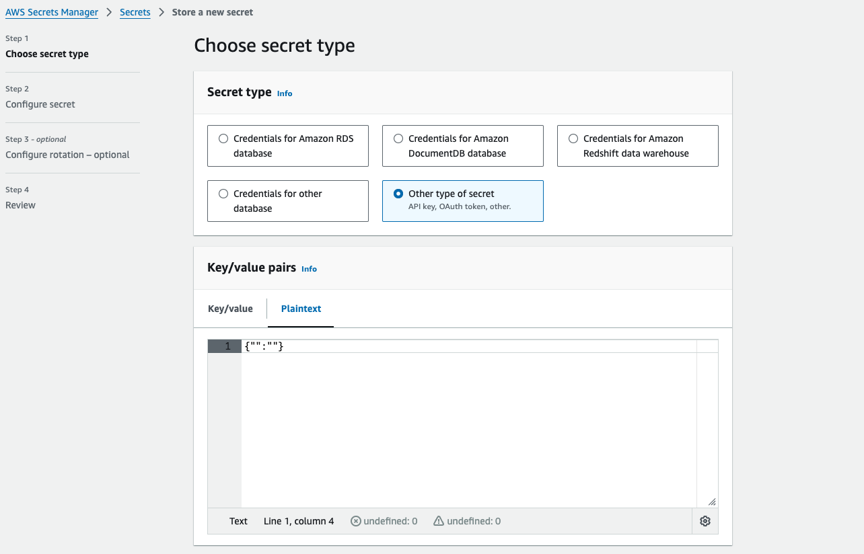

Deploying the initial Pipelines
- Create a CloudFormation stack using this template (‘Upload a template file’).
- Leave the parameters as their defaults, ensure you’ve selected S3 not code commit in the ‘Config Repository Configuration’. Code commit has been deprecated and will be removed in future versions. Acknowledge, click next and submit.
- The CloudFormation template will deploy the AWSAccelerator-InstallerPipeline, this will in turn produce a series of CloudFormation stacks that prepare the deployment pipeline.
- The deployment pipeline (AWSAccelerator-Pipeline) triggers after the Install pipeline has completed. This pipeline deploys multiple CloudFormation templates for separate components for the LZA which includes a Control Tower orchestrated Organisation setup & configuration of org wide CloudTrail, policies and alarms; enabling SecurityHub and GuardDuty (optionally Macie); Deploying IAM Identity Centre SSO; configuring a log archive account and associated Kinesis streams and deploying a basic network configuration into the Networking account.
Note: Cancel the deployment pipeline or it will error out if this is the first deployment and you haven’t updated the configuration in S3, this is described in the below sections.

Pipelines Overview

Installer Pipeline
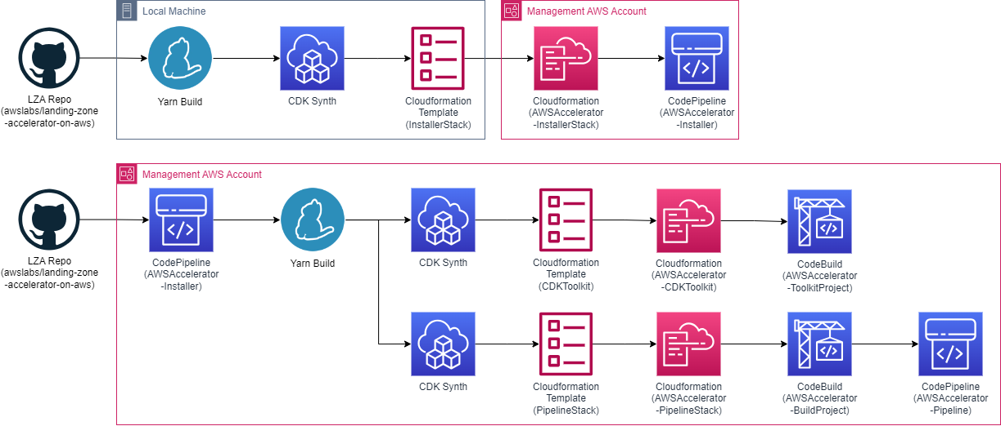
The Installer Pipeline deploys all the necessary resources for the LZA deployment pipeline, there is no need to build the initial Cloudformation template from scratch but it’s included in the diagram for completeness

Deployment Pipeline
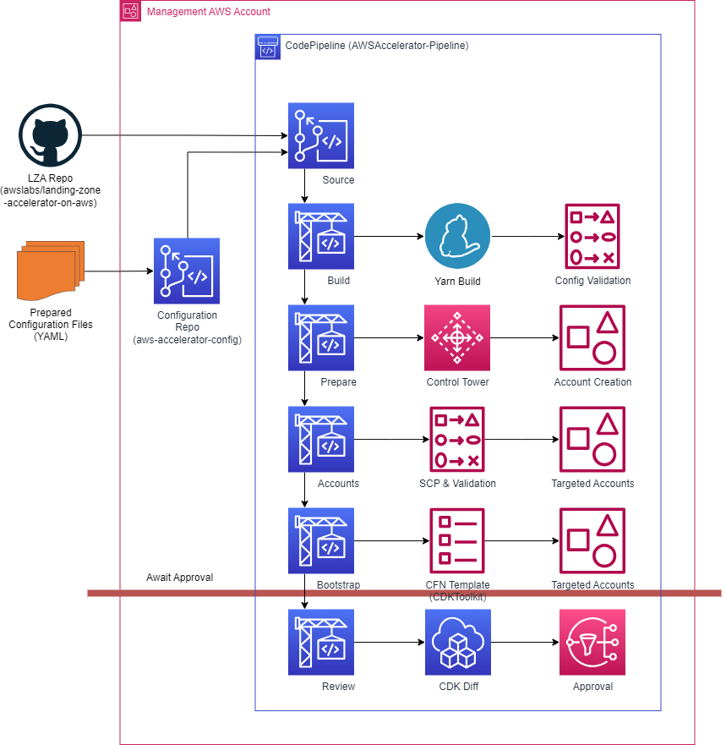
The deployment pipeline has several validation and preparation stages, these include deploying new accounts and configuring control tower, service control policies, creating new accounts and prepping accounts for the LZA deployment, it then pauses awaiting approval
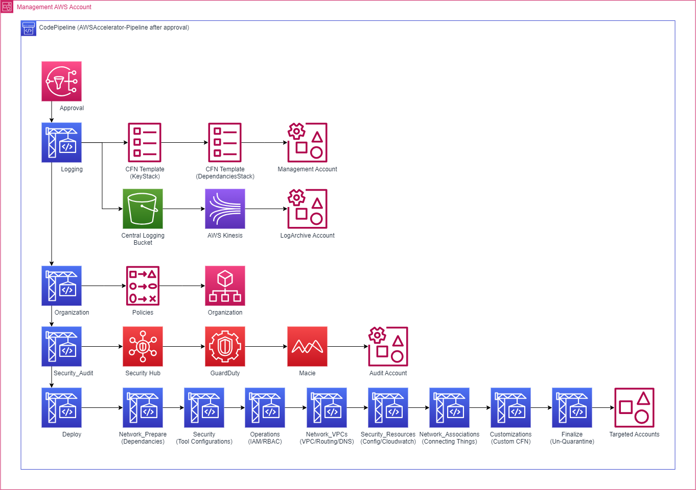
After the approval has been granted, it deploys the LZA in the order shown above, enabling features as per the configuration in S3.

Configuring the LZA

What are the Configuration Files?
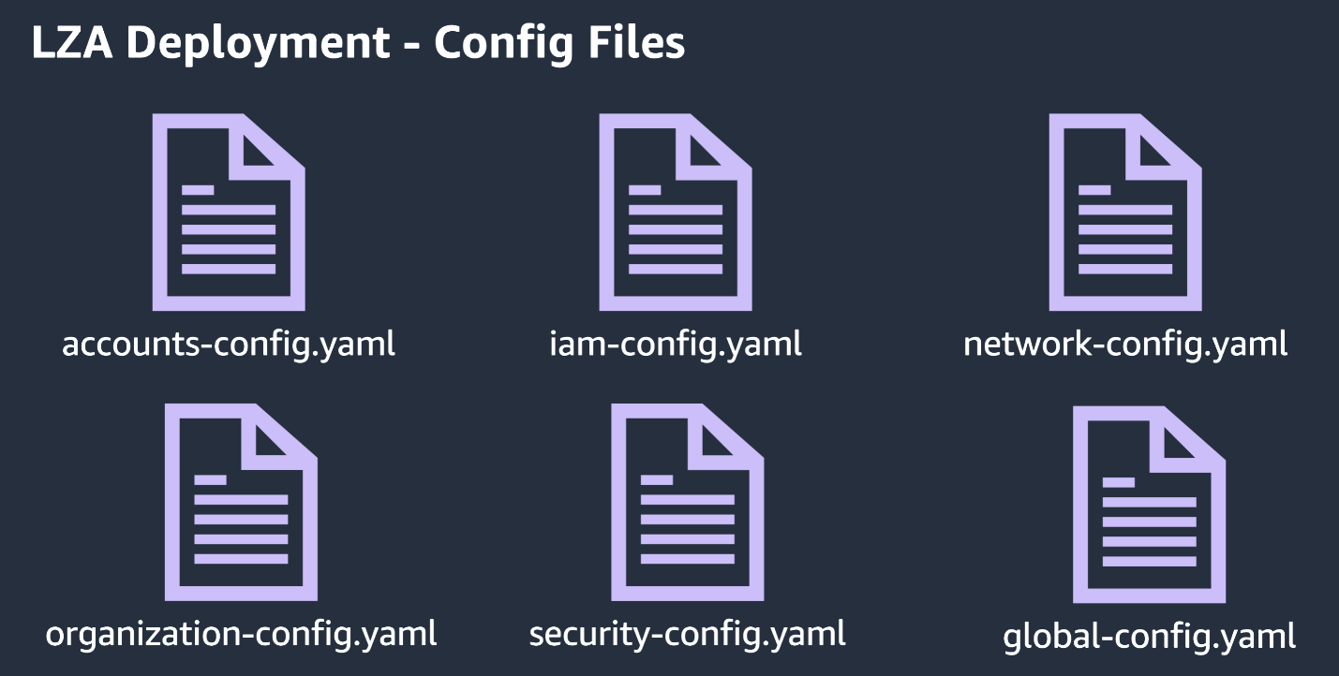
Extensive details on what exactly can be configured can be found here:
Services, Features, and Configuration References - Landing Zone Accelerator on AWS
See below for a brief overview of each:
- The Account Configuration file (accounts-config.yaml)
  - Manages the AWS accounts within the AWS Organisation. Adding any new accounts to this file will be replicated onto the LZA on AWS.
  - This file can be managed by adding a (primary) management account which holds root authority within the OU, alongside any other sub-accounts.
  - Details such as their email, brief description of the account would be placed here.
- The Global Configuration (global-config.yaml)
  - Manages the global properties inherited from AWS Organisation.
  - This also includes adding details for resources pertaining to the LZA which includes, but is not limited towhich user may receieve / be subscribed to SNS topics, the activity of AWS Session Manager, alongside lifecycle rules in relation to the expiry of bucket resources within S3.

- IAM Configuration (iam-config.yaml)
  - Governs all IAM resources across the AWS Organisation.
  - In addition to your default roles with root privileges, you may also add other roles with Administrator Access, or other more stringent permissions to ensure additional and greater security.
- Network Configuration (network-config.yaml)
  - Manages and implements network resources necessary to support cloud operations across workloads in AWS, including but not limited to Gateways, Loadbalancers, VPCs, Services and Endpoints.
  - Here you’ll be able to manage and edit your network topology, provisioning the necessary components for network security.
- AWS Organisation Configuration (organization-config.yaml)
  - Manages Organisational Units (OUs) and policies in the AWS Organisation.
  - Here you’ll be able to govern the policy capabilities of deployed tools and technologies such as, but not limited to, Amazon Guardrail in order to ensure greater security for your OU’s.
  - You can apply the policies in JSON files which can be configured to provide and apply policies.
- Security Configuration (security-config.yaml)
  - Governs and configures the AWS security services.
  - Security policies can be applied to AWS services such as managing log metrics, applying alarms in the event of service failures, security breaches or changes to cloud trail.
- Customisation Configuration (customizations-config.yaml)
  - Allows configuring custom applications and CloudFormation (CF) stacks.
  - This doesn’t need to be used unless there is a heavily customised landing zone deployed, see the link above these points for usage.

Editing the configuration files
- The Configuration Files are located in the S3 bucket provisioned via the cloudformation stack.
- It will follow the naming convention ‘aws-accelerator-config-*ACCOUNT-ID*-*REGION*’.
- From within there, you will find a zipped folder with a file within - aws-accelerator-config.zip. Unzip the file and use an editor of choice to reconfigure the contents of the file.
- Once editing is complete, re-zip the files and upload them to the original location.
- Below is an example of reuploading the zipped file, note that the zipped file cannot have a root folder, from the extracted folder on macOS run `zip –r aws-accelerator-config.zip` Windows doesn’t have this issue.
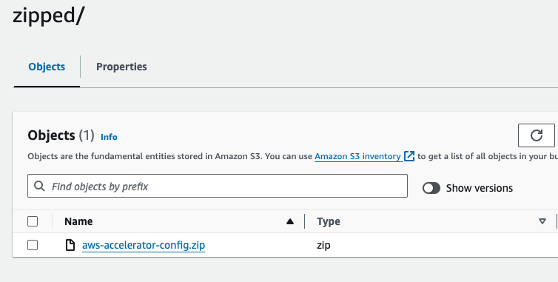

Head over to the AWSAccelerator-Pipeline on CodePipeline, and click on Release Changes. This will revision the previous source, utilising the more recently updated config files.
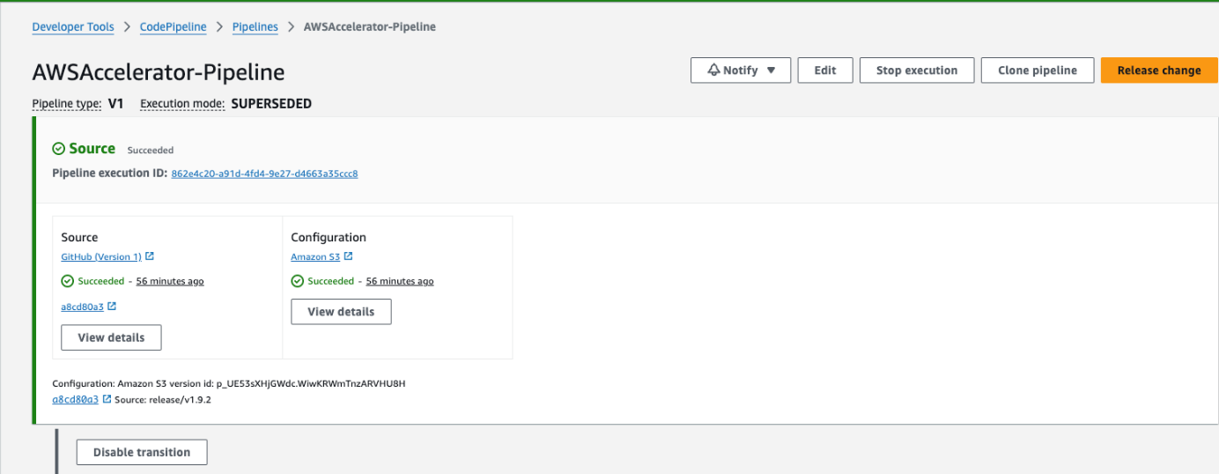
If done correctly, the pipeline should look something like this.
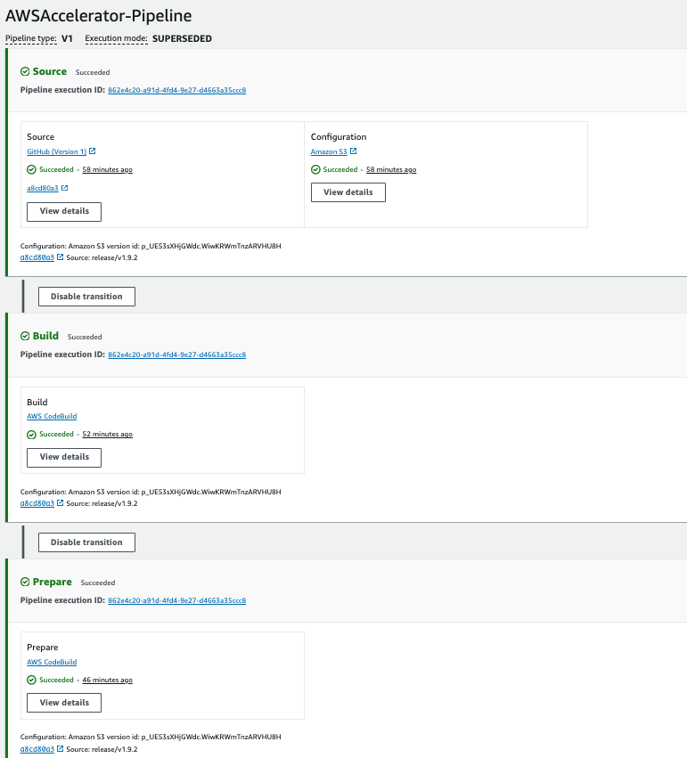

Why there are configuration files
- To adequately set up your AWS LZA, certain changes are necessary to make this work. Although most of this would have already been handled via the standard package, supplementary configuration is provided via the config files.
- Additional information regarding the structure, format and contents of the Configuration files can be located here:
  - AWS Landing Zone Config Guide
  - AWS Landing Zone GitHub Page
- The Landing Zone Guide provides a detailed understanding of the different components contained within the configuration file, and how these are to be implemented.
- The Landing Zone GitHub page provides a detailed layout and structure as to how the configuration files are to be structured.
- The configuration files are consumed by the Installer pipeline detailed above, they set the parameters for the cloudformation stacks that are deployed.

Troubleshooting

I’m having errors in relation to my configuration files during the Pipeline run.
If you’ve made any modifications and / or changes to any of the configuration files (creating further resources, enabling particular services and components which hadn’t been activated already) ensure that they not only meet YAML’s linting protocol, but are in-line with the base configuration that is being added.
Downloading and installing cfn-lint on your terminal, alongside a CloudFormation Linter on a code editor would help optimise the debugging process should such an issue arise.
In relation to any latter issues, strictly following the configuration references will ensure that you’re provisioning AWS resources within the LZA correctly.

My Pipeline is failing even though I’ve updated the S3 Bucket with a new zipped file.
Ensure that you choose Release Change and not Retry Failed Steps, as the former will not update the changes, but simply re-run your config files from the previous revision.

My Pipeline failed and the Cloudformation Stack is in ROLLBACK_COMPLETE
The CodePipeline is based on CDK, this deploys Cloudformation (CFN) templates to enact the changes required, you will not be able to redeploy a CFN template in a ROLLBACK_COMPLETE state, you must remove the stack – after the initial deployment, CDK uses changesets so you shouldn’t see any ROLLBACK_COMPLETE states but the pipeline may still fail

